ASSIGNMENT 1

1) Write a C# Sharp program that takes three letters as input and display

them in reverse order.

using System;

using System.Collections.Generic;

using System.Linq;

using System.Text;

using System.Threading.Tasks;

namespace Reversestring

{

class Program

{

static void Main(string[] args)

{

char letter, letter1, letter2;

Console.Write("Enter letter: ");

letter = Convert.ToChar(Console.ReadLine());

Console.Write("Enter letter: ");

letter1 = Convert.ToChar(Console.ReadLine());

Console.Write("Enter letter: ");

letter2 = Convert.ToChar(Console.ReadLine());

Console.WriteLine("{0} {1} {2}", letter2, letter1, letter);

Console.ReadKey();

}

}

}

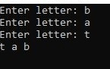

2) Write a C# Sharp program that takes a number and a width also a number, as input and then displays a triangle of that width, using that number.

using System;

using System.Collections.Generic;

using System.Linq;

using System.Text;

using System.Threading.Tasks;

namespace Triangle

{

class Program

{

static void Main(string[] args)

{

Console.Write("Enter a number: ");

int num = Convert.ToInt32(Console.ReadLine());

Console.Write("Enter the desired width: ");

int width = Convert.ToInt32(Console.ReadLine());

int height = width;

for (int row = 0; row < height; row++)

{

for (int column = 0; column < width; column++)

{

Console.Write(num);

}

Console.WriteLine();

width--;

Console.ReadKey();

}

}

}

}

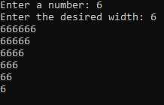

3)Write a C# Sharp program that takes userid and password as input (type string). After 3 wrong attempts, user will be rejected.(Store user data in hashtable/Dictionary)

using System;

using System.Collections.Generic;

using System.Linq;

using System.Text;

using System.Threading.Tasks;

namespace password

{

class Program

{

static void Main(string[] args)

{

string username, password;

int ctr = 0, dd = 0;

Console.Write("\n\nCheck username and password :\n");

Console.Write("N.B. : Defaule username and password is : username and password\n");

Console.Write("---------------------------------\n");

Console.ReadKey();

do

{

Console.Write("Input a username: ");

username = Console.ReadLine();

Console.Write("Input a password: ");

password = Console.ReadLine();

if (username == "username" && password == "password")

{

dd = 1;

ctr = 3;

}

else

{

dd = 0;

ctr++;

}

}

while ((username != "username" || password != "password")

&& (ctr != 3));

if (dd == 0)

{

Console.Write("\nLogin attemp more than three times. Try later!\n\n");

}

else

if (dd == 1)

{

Console.Write("\nPassword entered successfull!\n\n");

Console.ReadKey();

}

}

}

}

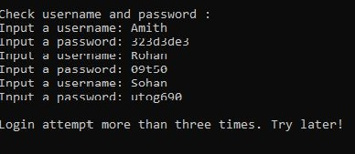

4)Write a C# Sharp program that takes two numbers as input and perform an operation (+,-,*,x,/) on them and displays the result of that operation.

using System;

using System.Collections.Generic;

using System.Linq;

using System.Text;

using System.Threading.Tasks;

namespace Operations

{

class Program

{

static void Main(string[] args)

{

int x, y;

char operation;

Console.Write("Input first number: ");

x = Convert.ToInt32(Console.ReadLine());

Console.Write("Input operation: ");

operation = Convert.ToChar(Console.ReadLine());

Console.Write("Input second number: ");

y = Convert.ToInt32(Console.ReadLine());

if (operation == '+')

Console.WriteLine("{0} + {1} = {2}", x, y, x + y);

else if (operation == '-')

Console.WriteLine("{0} - {1} = {2}", x, y, x - y);

else if ((operation == 'x') || (operation == '*'))

Console.WriteLine("{0} * {1} = {2}", x, y, x * y);

else if (operation == '/')

Console.WriteLine("{0} / {1} = {2}", x, y, x / y);

else

Console.WriteLine("Wrong Character");

Console.ReadKey();

}

}

}

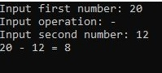

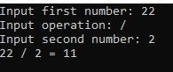

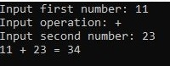

5)Write a C# Sharp program that takes the radius of a circle as input and calculate the perimeter and area of the circle

using System;

using System.Collections.Generic;

using System.Linq;

using System.Text;

using System.Threading.Tasks;

namespace Circle

{

class Program

{

static void Main(string[] args)

{

double r, per_cir;

double PI = 3.14;

Console.WriteLine("Input the radius of the circle : ");

r = Convert.ToDouble(Console.ReadLine());

per_cir = 2 * PI * r;

Console.WriteLine("Perimeter of Circle : {0}", per_cir);

Console.Read();

}

}

}

C:\Users\Nameera\Desktop\Circ output5newn.jpg

6)Write a C# Sharp program that takes distance and time as input and displays the speed in kilometres per hour and miles per hour.

using System;

using System.Collections.Generic;

using System.Linq;

using System.Text;

using System.Threading.Tasks;

namespace Distance

{

class Program

{

static void Main(string[] args)

{

float distance;

float hour, min, sec;

float timeSec;

float mps;

float kph, mph;

Console.Write("Input distance(metres): ");

distance = Convert.ToSingle(Console.ReadLine());

Console.Write("Input timeSec(hour): ");

hour = Convert.ToSingle(Console.ReadLine());

Console.Write("Input timeSec(minutes): ");

min = Convert.ToSingle(Console.ReadLine());

Console.Write("Input timeSec(seconds): ");

sec = Convert.ToSingle(Console.ReadLine());

timeSec = (hour * 3600) + (min * 60) + sec;

mps = distance / timeSec;

kph = (distance / 1000.0f) / (timeSec / 3600.0f);

mph = kph / 1.609f;

Console.WriteLine("Your speed in metres/sec is {0}", mps);

Console.WriteLine("Your speed in km/h is {0}", kph);

Console.WriteLine("Your speed in miles/h is {0}", mph);

Console.ReadKey();

}

}

}

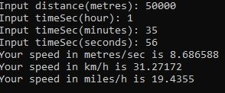

7)Write a C# Sharp program that takes a character as input and check the input (lowercase) is a vowel, a digit, or any other symbol.

using System;

using System.Collections.Generic;

using System.Linq;

using System.Text;

using System.Threading.Tasks;

namespace Vowel

{

class Program

{

static void Main(string[] args)

{

char symbol;

Console.Write("Input a symbol: ");

symbol = Convert.ToChar(Console.ReadLine());

if ((symbol == 'a') || (symbol == 'e') || (symbol == 'i') ||

(symbol == 'o') || (symbol == 'u'))

Console.WriteLine("It's a lowercase vowel.");

else if ((symbol >= '0') && (symbol <= '9'))

Console.WriteLine("It's a digit.");

else

Console.Write("It's another symbol.");

Console.ReadKey();

}

}

}

C:\Users\Nameera\Desktop\Output vowel7newn.jpg

C:\Users\Nameera\Desktop\Output 7.1newn.jpg

C:\Users\Nameera\Desktop\output7.2newn.jpg

8)Write a C# Sharp program that takes two numbers as input and returns true or false when both numbers are even or odd.

using System;

using System.Collections.Generic;

using System.Linq;

using System.Text;

using System.Threading.Tasks;

namespace oddeven

{

class Program

{

static void Main(string[] args)

{

int n1, n2;

bool bothEven;

Console.Write("Input First number: ");

n1 = Convert.ToInt32(Console.ReadLine());

Console.Write("Input Second number: ");

n2 = Convert.ToInt32(Console.ReadLine());

bothEven = ((n1 % 2 == 0)

&& (n2 % 2 == 0)) ? true : false;

Console.WriteLine(bothEven ?

"Both the numbers are Even" :

"Both the numbers are odd");

Console.ReadKey();

}

}

}

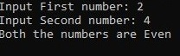

C:\Users\Nameera\Desktop\output8.1newn.jpg

9)Write a C# Sharp program that takes a decimal number as input and displays its equivalent in binary form.

using System;

using System.Collections.Generic;

using System.Linq;

using System.Text;

using System.Threading.Tasks;

namespace Decimal

{

class Program

{

static void Main(string[] args)

{

string answer;

string result;

Console.Write("Number to Convert : ");

answer = Console.ReadLine();

int num = Convert.ToInt32(answer);

result = "";

while (num > 1)

{

int remainder = num % 2;

result = Convert.ToString(remainder) + result;

num /= 2;

}

result = Convert.ToString(num) + result;

Console.WriteLine("Binary: {0}", result);

Console.ReadKey();

}

}

}

C:\Users\Nameera\Desktop\output 9new.jpg

10)Write a C# Sharp program to get the absolute difference between n and 51. If n is greater than 51 return triple the absolute difference.

using System;

using System.Collections.Generic;

using System.Linq;

using System.Text;

using System.Threading.Tasks;

namespace Absolutedifference

{

class Program

{

static void Main(string[] args)

{

Console.WriteLine(test(53));

Console.WriteLine(test(30));

Console.WriteLine(test(51));

Console.ReadLine();

}

public static int test(int n)

{

const int x = 51;

if (n > x)

{

return (n - x) * 3;

}

return x - n;

Console.ReadKey();

}

}

}

C:\Users\Nameera\Desktop\Output10new.jpg

11)Write a C# Sharp program to remove the character in a given position of a given string. The given position will be in the range 0.. string length -1 inclusive.

using System;

using System.Collections.Generic;

using System.Linq;

using System.Text;

using System.Threading.Tasks;

namespace python

{

class Program

{

static void Main(string[] args)

{

Console.WriteLine(test("Python", 1));

Console.WriteLine(test("Python", 0));

Console.WriteLine(test("Python", 4));

Console.ReadLine();

}

public static string test(string str, int n)

{

return str.Remove(n, 1);

}

}

}

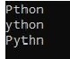

12) Write a C# Sharp program to exchange the first and last characters in a given string and return the new string.

using System;

using System.Collections.Generic;

using System.Linq;

using System.Text;

using System.Threading.Tasks;

namespace Exchange

{

class Program

{

static void Main(string[] args)

{

Console.WriteLine(test("abcd"));

Console.WriteLine(test("a"));

Console.WriteLine(test("xy"));

Console.ReadLine();

}

public static string test(string str)

{

return str.Length > 1

? str.Substring(str.Length - 1) + str.Substring(1, str.Length - 2) + str.Substring(0, 1) : str;

Console.ReadKey();

}

}

}

C:\Users\Nameera\Desktop\output12new.jpg

13) write a c# program to create a new array from two give array of integers, each length 3

namespace exercises

{

class Program

{

static void Main(string[] args)

{

int[] item = test(new[] { 10, 20, 30 }, new[] { 40, 50, 60 });

Console.Write("New array: ");

foreach(var i in item)

{

Console.Write(i.ToString()+" ");

}

}

public static int[] test(int[] nums1, int [] nums2)

{

return new int[] { nums1[0], nums1[1], nums1[2], nums2[0], nums2[1], nums2[2] };

}

}

}

14)Write a C# Sharp program to count the number of strings with given length in given array of strings.

using System;

using System.Collections.Generic;

using System.Linq;

using System.Text;

using System.Threading.Tasks;

namespace stringlength

{

class Program

{

static void Main(string[] args)

{

{

Console.WriteLine("Number of Strings: ");

Console.WriteLine(test(new[] { "a", "b", "bb", "c", "ccc" }, 1));

Console.ReadKey();

}

int test(string[] arr_str, int len)

{

int ctr = 0;

for (int i = 0; i < arr_str.Length; i++)

{

if (arr_str[i].Length == len) ctr++;

}

return ctr;

}

}

}

}

C:\Users\Nameera\Desktop\output14newm.jpg

15) Write a C# Sharp program to calculate the value that results from raising 3 to a power ranging from 0 to 32.

using System;

using System.Collections.Generic;

using System.Linq;

using System.Text;

using System.Threading.Tasks;

namespace Power

{

class Program

{

static void Main(string[] args)

{

int value = 3;

for (int power = 0; power <= 32; power++)

Console.WriteLine($"{value}^{power} = {(long)Math.Pow(value, power):N0} (0x{(long)Math.Pow(value, power):X})");

Console.ReadKey();

}

}

}

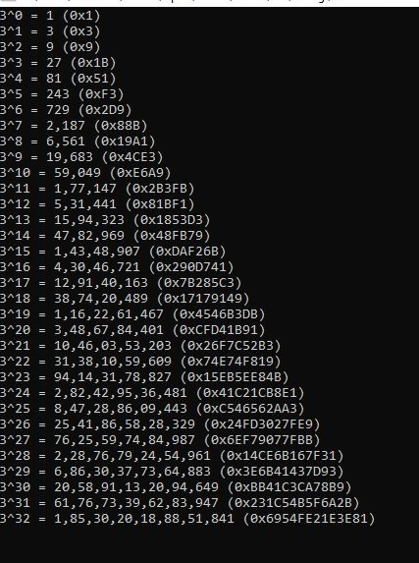

16)Write a C# Sharp program to convert a given integer value to Roman numerals.

using System;

using System.Collections.Generic;

using System.Linq;

using System.Text;

using System.Threading.Tasks;

namespace Roman

{

class Program

{

static void Main(string[] args)

{

int n;

n = 2365;

Console.WriteLine("Original integer value: " + n);

Console.WriteLine("Roman numerals of the said integer value:");

Console.WriteLine(int_to_Roman(n));

n = 254;

Console.WriteLine("Original integer value: " + n);

Console.WriteLine("Roman numerals of the said integer value:");

Console.WriteLine(int_to_Roman(n));

n = 45;

Console.WriteLine("Original integer value: " + n);

Console.WriteLine("Roman numerals of the said integer value:");

Console.WriteLine(int_to_Roman(n));

n = 8;

Console.WriteLine("Original integer value: " + n);

Console.WriteLine("Roman numerals of the said integer value:");

Console.WriteLine(int_to_Roman(n));

Console.ReadKey();

}

public static string int_to_Roman(int n)

{

string[] roman_symbol = { "MMM", "MM", "M", "CM", "DCCC", "DCC", "DC", "D", "CD", "CCC", "CC", "C", "XC", "LXXX", "LXX", "LX", "L", "XL", "XXX", "XX", "X", "IX", "VIII", "VII", "VI", "V", "IV", "III", "II", "I" };

int[] int_value = { 3000, 2000, 1000, 900, 800, 700, 600, 500, 400, 300, 200, 100, 90, 80, 70, 60, 50, 40, 30, 20, 10, 9, 8, 7, 6, 5, 4, 3, 2, 1 };

var roman_numerals = new StringBuilder();

var index_num = 0;

while (n != 0)

{

if (n >= int_value[index_num])

{

n -= int_value[index_num];

roman_numerals.Append(roman_symbol[index_num]);

}

else

{

index_num++;

}

}

return roman_numerals.ToString();

}

}

}

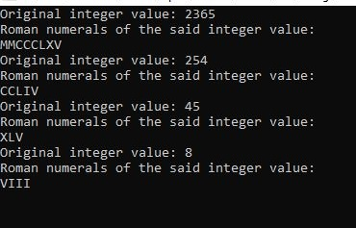

17)Write a program in C# Sharp to find the sum of first n natural numbers using recursion.

using System;

using System.Collections.Generic;

using System.Linq;

using System.Text;

using System.Threading.Tasks;

namespace Naturalnumbers

{

class Program

{

static void Main(string[] args)

{

Console.Write(" How many numbers to sum : ");

int n = Convert.ToInt32(Console.ReadLine());

Console.Write(" The sum of first {0} natural numbers is : {1}\n\n", n, SumOfTen(1, n));

Console.ReadKey();

}

static int SumOfTen(int min, int max)

{

return CalcuSum(min, max);

}

static int CalcuSum(int min, int val)

{

if (val == min)

return val;

return val + CalcuSum(min, val - 1);

}

}

}

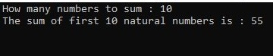

18) Write a program in C# Sharp to find the number of an array and the square of each number using LINQ.

using System;

using System.Collections.Generic;

using System.Linq;

using System.Text;

using System.Threading.Tasks;

namespace Squareroot

{

class Program

{

static void Main(string[] args)

{

var arr1 = new[] { 3, 9, 2, 8, 6, 5 };

var sqNo = from int Number in arr1

let SqrNo = Number * Number

where SqrNo > 20

select new { Number, SqrNo };

foreach (var a in sqNo)

Console.WriteLine(a);

Console.ReadKey();

}

}

}

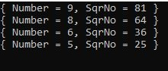

19) Write a program in C# Sharp to display the characters and frequency of character from giving string using LINQ.

using System;

using System.Collections.Generic;

using System.Linq;

using System.Text;

using System.Threading.Tasks;

namespace Characters

{

class Program

{

static void Main(string[] args)

{

string str;

Console.Write("Input the string : ");

str = Console.ReadLine();

Console.Write("\n");

var FreQ = from x in str

group x by x into y

select y;

Console.Write("The frequency of the characters are :\n");

foreach (var ArrEle in FreQ)

{

Console.WriteLine("Character " + ArrEle.Key + ": " + ArrEle.Count() + " times");

Console.ReadKey();

}

}

}

}

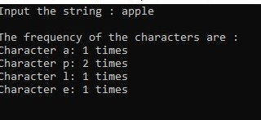

20)Write a program in C# Sharp to find the string which starts and ends with a specific character using LINQ .

using System;

using System.Collections.Generic;

using System.Linq;

using System.Text;

class Program

{

static void Main(string[] args)

{

string chst,chen;

char ch,ch1;

string[] cities =

{

"ROME","LONDON","NAIROBI","CALIFORNIA","ZURICH","NEW DELHI","AMSTERDAM","ABU DHABI", "PARIS"

};

Console.Write("\nThe cities are : 'ROME','LONDON','NAIROBI','CALIFORNIA','ZURICH','NEW DELHI','AMSTERDAM','ABU DHABI','PARIS' \n");

Console.Write("\nInput starting character for the string : ");

ch = Convert.ToChar(Console.ReadLine());

chst=ch.ToString();

Console.Write("\nInput ending character for the string : ");

ch1 = Convert.ToChar(Console.ReadLine());

chen=ch1.ToString();

var _result = from x in cities

where x.StartsWith(chst)

where x.EndsWith(chen)

select x;

foreach(var city in _result)

{

Console.Write("The city starting with {0} and ending with {1} is : {2} \n", chst,chen,city);

}

Console.ReadLine();

}

}

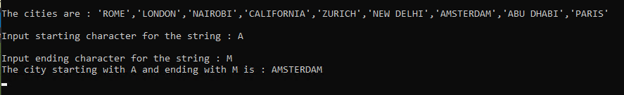

21) Write a program in C# Sharp to display the top n-th records using LINQ.

using System;

using System.Collections.Generic;

using System.Linq;

using System.Text;

using System.Threading.Tasks;

namespace nth_records

{

class Program

{

static void Main(string[] args)

{

List<int> templist = new List<int>();

templist.Add(5);

templist.Add(7);

templist.Add(13);

templist.Add(24);

templist.Add(6);

templist.Add(9);

templist.Add(8);

templist.Add(7);

Console.WriteLine("\nThe members of the list are : ");

foreach (var lstnum in templist)

{

Console.WriteLine(lstnum + " ");

}

Console.Write("How many records you want to display ? : ");

int n = Convert.ToInt32(Console.ReadLine());

templist.Sort();

templist.Reverse();

Console.Write("The top {0} records from the list are : \n", n);

foreach (int topn in templist.Take(n))

{

Console.WriteLine(topn);

Console.ReadKey();

}

}

}

}

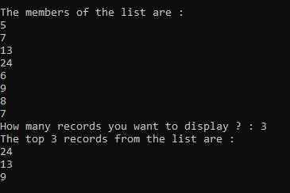

22) write a program in c# to count file extension and group it using LINQ

using System;

using System.Collections.Generic;

using System.Linq;

using System.Text;

using System.IO;

class LinqExercise15

{

public static void Main()

{

string[] arr1 = { "aaa.frx", "bbb.TXT", "xyz.dbf","abc.pdf", "aaaa.PDF","xyz.frt", "abc.xml", "ccc.txt", "zzz.txt" };

Console.Write("\nThe files are : aaa.frx, bbb.TXT, xyz.dbf,abc.pdf");

Console.Write("\n aaaa.PDF,xyz.frt, abc.xml, ccc.txt, zzz.txt\n");

Console.Write("\nHere is the group of extension of the files : \n\n");

var fGrp = arr1.Select(file => Path.GetExtension(file).TrimStart('.').ToLower())

.GroupBy(z => z,(fExt, extCtr) =>new

{

Extension = fExt,

Count = extCtr.Count()

});

foreach (var m in fGrp)

Console.WriteLine("{0} File(s) with {1} Extension ",m.Count, m.Extension);

Console.ReadLine();

}

}

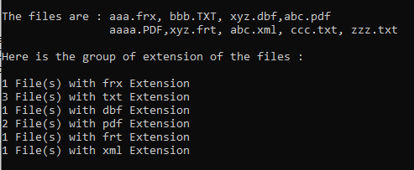

ASSIGNMENT 2

1)Write the C# code to display “<n> minute(s) ago" if difference between both dates is less than an hour and “<n> hour(s) ago" if the difference is less than a day and “<n> day(s) ago" if the difference is less than a month and the date if the difference is more than a month.

using System;

public class Program

{

public static void Main()

{

var prevDate = new DateTime(2021, 7, 15);

var today = DateTime.Now;

Console.WriteLine("prevDate: {0}", prevDate);

Console.WriteLine("today: {0}", today);

var diffOfDates = today.Subtract(prevDate);

Console.WriteLine("Difference in Days: {0}", diffOfDates.Days);

Console.WriteLine("Difference in Hours: {0}", diffOfDates.Hours);

Console.WriteLine("Difference in Miniutes: {0}", diffOfDates.Minutes);

}

}

Write a program in C# Sharp to create and read last n number of li file nes of a . [Go to the editor](https://www.w3resource.com/csharp-exercises/file-handling/index.php#editorr)

using System;

using System.IO;

class filexercise14

{

static void Main()

{

string fileName = @"mytest.txt";

string[] ArrLines ;

int n,i,l,m=1;

if (File.Exists(fileName))

{

File.Delete(fileName);

}

Console.Write(" Input number of lines to write in the file :");

n= Convert.ToInt32(Console.ReadLine());

ArrLines=new string[n];

Console.Write(" Input {0} strings below :\n",n);

for(i=0;i<n;i++)

{

Console.Write(" Input line {0} : ",i+1);

ArrLines[i] = Console.ReadLine();

}

System.IO.File.WriteAllLines(fileName, ArrLines);

Console.Write("\n Input last how many numbers of lines you want to display :");

l = Convert.ToInt32(Console.ReadLine());

m=l;

if(l>=1 && l<=n)

{

Console.Write("\n The content of the last {0} lines of the file {1} is : \n",l,fileName);

if (File.Exists(fileName))

{

for(i=n-l;i<n;i++)

{

string[] lines = File.ReadAllLines(fileName);

Console.Write(" The last no {0} line is : {1} \n",m,lines[i]);

m--;

}

}

}

Else

{ Console.WriteLine(" Please input the correct line no.");

}

Console.WriteLine();

}

}

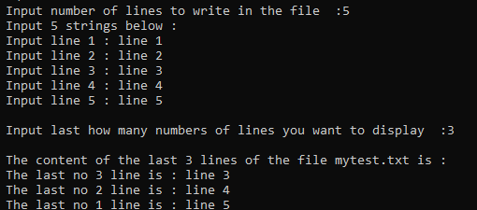

1. Write a function:

class Solution { public int solution(int[] A); }

that, given an array A of N integers, returns the smallest positive integer (greater than 0) that does not occur in A.

For example, given A = [1, 3, 6, 4, 1, 2], the function should return 5.

Given A = [1, 2, 3], the function should return 4.

Given A = [−1, −3], the function should return 1.

Assume that:

N is an integer within the range [1..100,000]; each element of array A is an integer within the range [−1,000,000..1,000,000]. Complexity:

using System;

using System.Collections.Generic;

using System.Linq;

using System.Text;

using System.Threading.Tasks;

namespace time

{

class Program

{

static int solution(int[] A)

{

int m = A.Max();

if (m < 1)

{

return 1;

}

if (A.Length == 1)

{

if (A[0] == 1)

{

return 2;

}

else

{

return 1;

}

}

int i = 0;

int[] l = new int[m];

for (i = 0; i < A.Length; i++)

{

if (A[i] > 0)

{

if (l[A[i] - 1] != 1)

{

l[A[i] - 1] = 1;

}

}

}

for (i = 0; i < l.Length; i++)

{

if (l[i] == 0)

{

return i + 1;

}

}

return i + 2;

}

public static void Main()

{

int[] A = { 1, 3, 6, 4, 1, 2 };

Console.WriteLine(solution(A));

Console.ReadKey();

}

}

}

C:\Users\admin\Pictures\Screenshots\Screenshot (58).png

5) Reverse the ordering of words in a String

using System;

using System.Collections.Generic;

using System.Linq;

using System.Text;

using System.Threading.Tasks;

namespace ReverseString2

{

class Program

{

static void reverse(char[] str,

int start, int end)

{

char temp;

while (start <= end)

{

temp = str[start];

str[start] = str[end];

str[end] = temp;

start++;

end--;

}

}

static char[] reverseWords(char[] s)

{

int start = 0;

for (int end = 0;

end < s.Length; end++)

{

if (s[end] == ' ')

{

reverse(s, start, end);

start = end + 1;

}

}

reverse(s, start, s.Length - 1);

reverse(s, 0, s.Length - 1);

return s;

}

static void Main(string[] args)

{

String s = "My name is X Y Z ";

char[] p = reverseWords(s.ToCharArray());

Console.Write(p);

Console.ReadKey();

}

}

}

C:\Users\Nameera\Desktop\output5ass2n.jpg